Ca 2

YouTube Video Platform

TANJIR AHMED BHUBAN

10616591

Table of Contents

1) System Architecture/Design Specification: 2

I. System Components: 2

✓ User Interface (UI): 2

✓ Backend Services: 2

✓ Database: 2

✓ Recommendation Engine: 2

✓ Admin Module: 3

II. Communication Flow: 3

✓ User Actions: 3

✓ Backend Operations: 3

✓ Database Interactions: 3

✓ Recommendation Engine: 3

✓ Admin Module: 3

2) Implementation 3

✓ IDE 4

✓ Language 4

✓ Paradigm 4

3) Test Cases: 4

✓ Test Case for uploading Video: 4

✓ Test Case for like Video: 5

✓ Test Case for commenting Video: 5

4) Project Plan Detailing Main Releases - Project Scope (Agile Scrum Model) 6

I. Agile Scrum Model 6

✓ Description: 6

✓ Scope Points: 6

✓ Release Planning: 6

✓ Sprint Planning: 6

✓ Sprints: 6

✓ User Feedback: 6

✓ Adjustments to Scope: 6

✓ Continuous Adaptation: 6

✓ Conclusion: 7

II. Main Releases 7

✓ Release 1: 7

✓ Features: 7

✓ Timeline: 7

✓ Release 2: 7

✓ Features: 7

✓ Timeline: 8

✓ Release 3: 8

✓ Features: 8

✓ Timeline: 8

✓ Release 4: 8

✓ Features: 8

✓ Timeline: 8

✓ Release 5: 8

✓ Activities: 9

✓ Timeline: 9

# System Architecture/Design Specification:

## System Components:

### User Interface (UI):

Activities for video playback, comments, likes, and playlist management.

UI components for displaying video details, comments, and user interactions.

### Backend Services:

**Video Service:**

Manages video-related operations (upload, retrieve, update statistics).

**Comment Service:**

Handles comments and interactions.

**User Service:**

Manages user-related actions (registration, login).

### Database:

Tables for storing video information, comments, user data, and playlists.

### Recommendation Engine:

Analyses user behaviour to provide personalized video recommendations.

### Admin Module:

Monitors content, reviews reports, and takes appropriate actions.

## Communication Flow:

### User Actions:

Uploads video, plays video, adds comments, likes videos, creates playlists.

### Backend Operations:

**Video Service:**

Processes uploads, updates view counts, and manages video statistics.

**Comment Service:**

Handles comments, likes, and user interactions.

**User Service:**

Manages user accounts and authentication.

### Database Interactions:

Video information, comments, and user data are stored and retrieved from the database

### Recommendation Engine:

Receives user behaviour data, analyses patterns, and suggests personalized video recommendations.

### Admin Module:

Admin Service monitors reported content, reviews, and takes appropriate actions.

# Implementation

Video class having functionality of liking video and commenting. Simple, implementation is done via Video class having video title and URL in constructor.

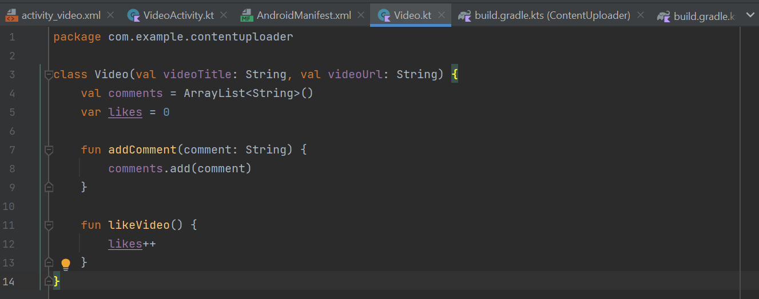

### IDE

Android Studio

### Language

Kotlin

### Paradigm

Object Oriented

# Test Cases:

### Test Case for uploading Video:

**Input:**

User uploads a video.

**Expected Output:**

Video is successfully uploaded, and relevant data is updated.

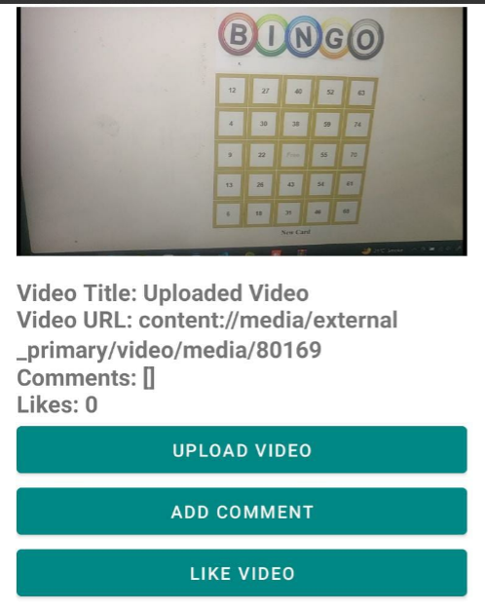

### Test Case for like Video:

**Input:**

User likes a video.

**Expected Output:**

Like count for the video is increased.

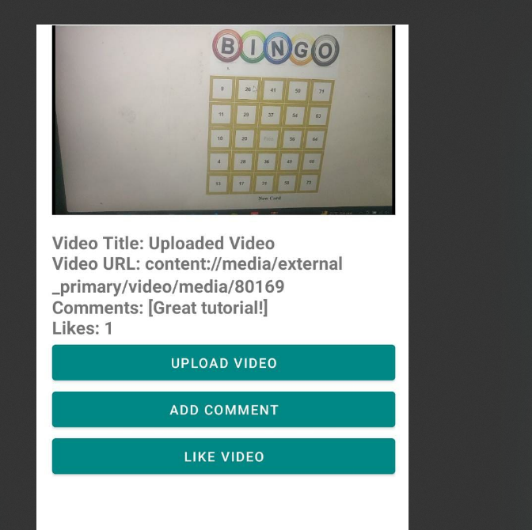

### Test Case for commenting Video:

**Input:**

User clicks on comment button for a video.

**Expected Output:**

Comment is added under video details.



# Project Plan Detailing Main Releases - Project Scope (Agile Scrum Model)

1. Agile Scrum Model

### Description:

Iterative and incremental approach where releases are delivered in short, time-boxed iterations called Sprints.

Emphasizes adaptability, flexibility, and continuous delivery of value.

### Scope Points:

The project plan follows the Agile principles, focusing on customer collaboration and responding to change.

Features and functionalities are organized as User Stories in the Product Backlog.

Each release corresponds to a set of completed User Stories, delivering a potentially shippable product increment.

### Release Planning:

High-level release planning involves prioritizing User Stories in the Product Backlog.

The Release Backlog is a subset of the Product Backlog for a specific release.

### Sprint Planning:

Before each Sprint, a Sprint Planning meeting is conducted to select and plan the implementation of the highest-priority User Stories from the Release Backlog.

### Sprints:

Time-boxed iterations (Sprints) typically last 2-4 weeks, resulting in a potentially shippable product increment at the end of each Sprint.

### User Feedback:

Regular Sprint Reviews provide an opportunity to gather user feedback on the completed features.

### Adjustments to Scope:

The scope for each release can be adjusted based on stakeholder feedback and changing priorities.

New User Stories can be added to the Product Backlog, and existing ones can be reprioritized.

### Continuous Adaptation:

The project team continuously adapts to changing requirements and customer needs throughout the development process.

### Conclusion:

The Agile Scrum Model allows for a dynamic and adaptive approach to project planning and scope management. The project plan details main releases as a series of Sprints, each delivering incremental value. Stakeholder feedback is integrated regularly, and the project team has the flexibility to adjust the scope based on changing requirements. This model is particularly well-suited for projects where there is a need for continuous adaptation to evolving priorities and customer feedback.

1. Main Releases

### Release 1:

Minimum Viable Product (MVP)

### Features:

User registration and authentication.

Video upload and playback.

Like and comment on videos.

Basic UI for video interactions.

### Timeline:

**Sprint 1:**

User authentication and registration.

**Sprint 2:**

Video upload and playback.

**Sprint 3:**

Like and comment features.

### Release 2:

Playlist Management

### Features:

Create and manage playlists.

Add videos to playlists.

### Timeline:

**Sprint 4:**

Playlist creation and management.

**Sprint 5:**

Add videos to playlists.

### Release 3:

Recommendation Engine

### Features:

Implement a basic recommendation engine.

Provide personalized video suggestions.

### Timeline:

**Sprint 6:**

Recommendation engine implementation.

### Release 4:

Admin Module

### Features:

Admin authentication and access.

Content monitoring and review.

### Timeline:

**Sprint 7:**

Admin authentication and access.

**Sprint 8:**

Content monitoring and review.

### Release 5:

Testing and Optimization

### Activities:

Comprehensive testing of all features.

Optimization for performance and user experience.

### Timeline:

**Sprint 9:**

Testing and bug fixes.

**Sprint 10:**

Optimization and final adjustments.